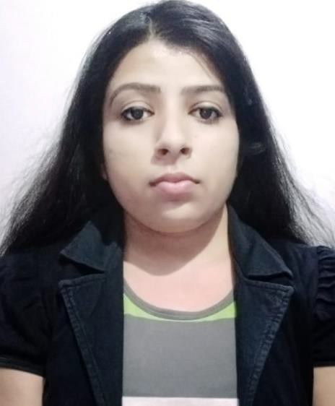

PRITY KUMARI

Contact

**Address:**

RD NO -14,QTR NO -50/1/2, ADITYAPUR-2,JAMSHEDPUR, JHARKHAND,PIN-831013

**Phone:**

+918697623656

**Email:**

[nitprity2015@gmail.com](mailto:nitprity2015@gmail.com)

**LinkedIn:** https://[www.linkedin.com/in/prit](http://www.linkedin.com/in/prit) y-kumari-133796223

Interpersonal skill

Good Team Member

Analytical skill

Hobbies

* Reading books
* Listening music

**CURRICULUM VITAE**

# Summary

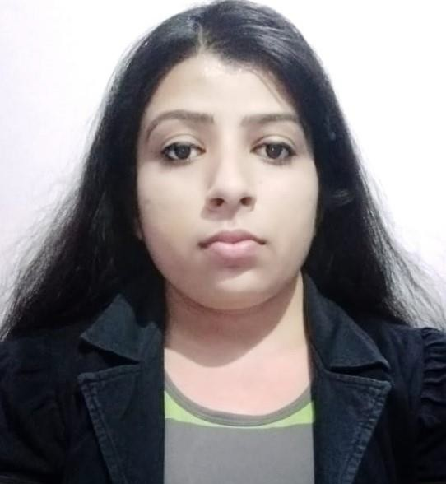IT FRESHER, Always eager to learn new skills. I am seeking a Software Developer role to enhance my knowledge and secure a responsible career opportunity to fully utilize my skills, while making a significant contribution to the success of the company.

# Skill Highlights



* Frontend Technologies:-

**HTML ,CSS, JavaScript, AJAX,**

**Bootstrap, Angular**

* Backend Technologies:- **Core Java ,Hibernate, Spring Boot RESTful Web Services**
* Database Systems:- **SQL and PL/SQL with MySQL**

# Education

* BACHELOR OF ENGINEERING:- INFORMATION TECHNOLOGY NARULA INSTITUTE OF TECHNOLOGY,KOLKATA, 2019 **PERCENTAGE:-** 73%
* HIGHER SECONDARY:- SCIENCE PK JHA COLLEGE, BIHAR, 2014 **PERCENTAGE:-** 57%
* SECONDARY :- GENERAL

ST. MARY’S HINDI HIGH SCHOOL, JHARKHAND, 2011

**PERCENTAGE: -** 77%

# PROJECTS

* Create Hotel Website(Final year college project) Used skill:- **Spring Boot, Angular**

Declaration

I do here by declare that the fact and informations given by me in the above application are true, complete and correct to the best of my knowledge and belief.

Prity Kumari Date-21.03.2023